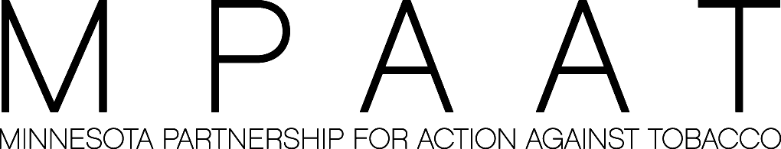

MEDIA ADVISORY
July 28, 2005 Contact: Andrea Mowery
Director of Marketing and Communications
(952) 767-1404

Health Impact Fee Goes Into Effect on August 1
Information and Spokespeople Available

The new Health Impact Fee goes into effect in Minnesota on August 1. Such states as Oklahoma
and New York experienced an increase in the number of people attempting to quit tobacco use
after enacting tobacco price increases.

Through its QUITPLANSM services, MPAAT provides individual stop-smoking services to any Minnesotan who wants to quit.

MPAAT is available to comment on all of its QUITPLAN services and on the expected rise in demand for its stop-smoking services.

MPAAT is an independent, non-profit organization that improves the health of Minnesotans by reducing the harm caused by tobacco. MPAAT serves Minnesota through its grant-making
program, QUITPLANSM stop-smoking services and statewide outreach activities. It is funded
with three percent of the state’s 1998 tobacco settlement.

- 30 -

